|  |  |
| --- | --- |
| Hardware Level of Completion | Completion |
| Batttery Monitor | 90% |
| Load Monitor | 60% |
| Ultrasonic sensor | 100% |
| Magnetometer implementation | 95% |
| H-Bridge implementation | 100% |
| Power distribution | 100% |
| Notification interface | 80% |

|  |
| --- |
| Work distribution table |
| Serial Drivers |
| PCB Design |
| Power Regulator Design |
| Battery Measurer Design |
| Current Sampler Design |
| Power Analysis |
| H-Bridge Interface |

Conclusion:

A long the path of this project we have been able to learn a lot. We learned an array of handful skills regarding microcontrollers and their utility such as serial communication, PWM generation, timers, hardware interfacing, the list goes on. Regarding to the boat design implementation we also learned a lot, things like sensors do not work as you ideally expect them to, this means that you have to be able to adapt your design to aspects that you did not expect. Your software has to be able to be modularized in order to be able to separate and conquer, this way you can be more efficient with your time. All of this complimSents a new view and respect that we have for the design and implementation of embedded systems and systems in general.

In the end we saw that it is possible to get an autonomous marine vehicle working in a relatively small amount of time, even if it is in a small scale. We got the boat to be controlled via Bluetooth application. The autonomous operation turned out to be the key obstacle, we got the sensors working but the autonomous mode required more debugging and fine tuning to be described as an efficient system. Certain functionalities of the system can also be improved. Overall it has been a great experience, and I know that all of these are considerations that we will take with us to future projects and into our careers.

Main board top

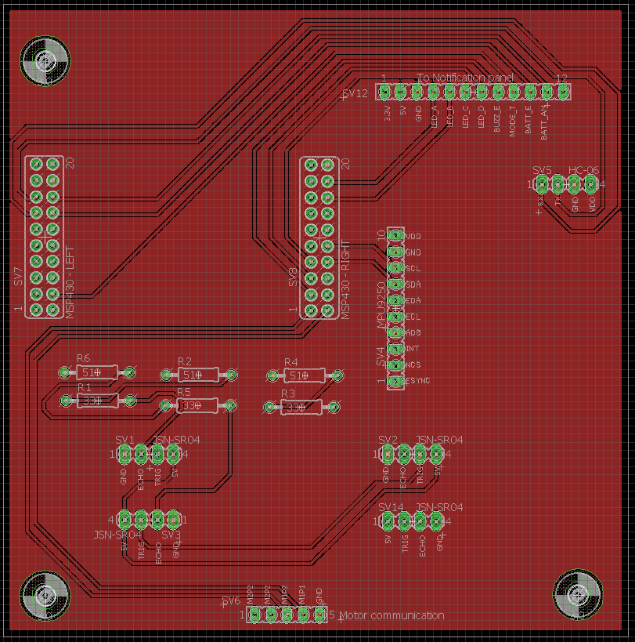

Main board bot

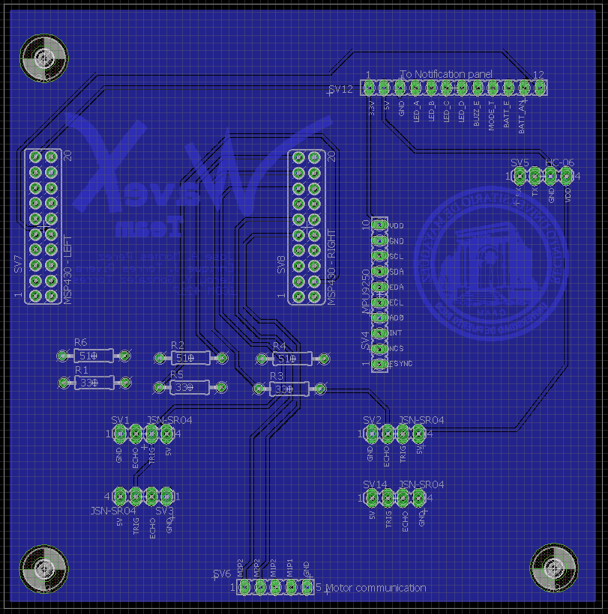

Notification Panel

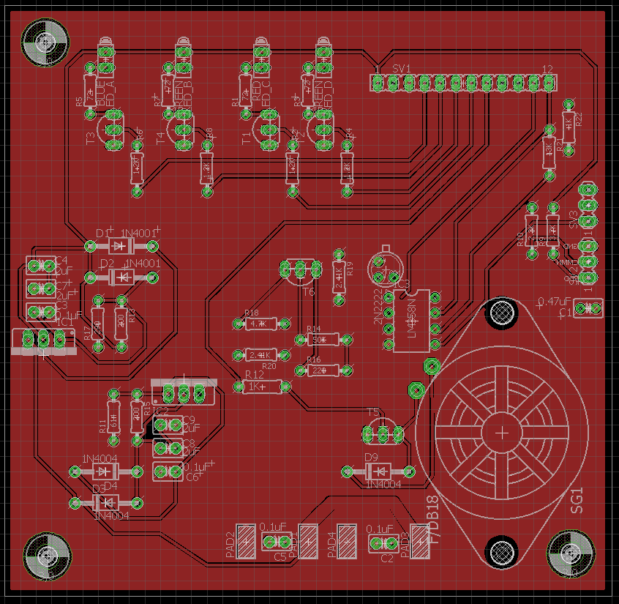

Notification Panel bottom

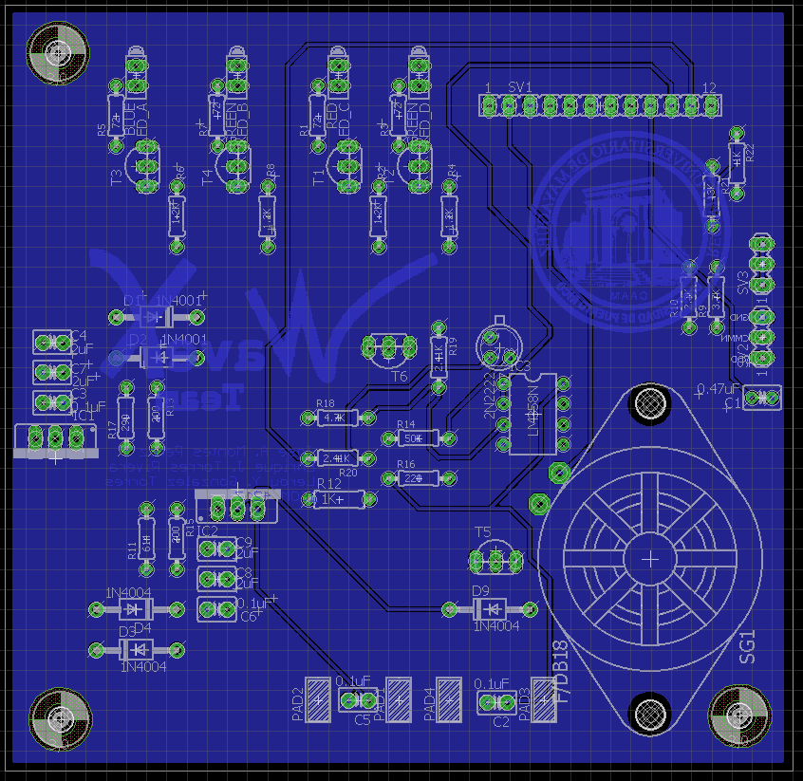

**Introduction**

Pools are located everywhere; from homes, community centers, parks and hotels…; in sort, all across the world. The problem is that they are filled with undesired and hard to clean debris. This can be an exhausting task for pool owners to do, especially if they do not have the time or cannot complete the task due to health reasons. This creates a market for a product that facilitates the maintenance of pools for a wide array of people. The goal of the WaveX team is to create a viable prototype of an embedded system that improves upon already established products that help with pool maintenance.

The system is not meant to compete directly with the service provided by pool cleaning companies; furthermore, it can complement their services. The companies can increase efficiency by cleaning the pool at the same time you complete other pertinent tasks. This reduces the amount of personnel that they require to offer their services.

The watercraft will autonomously cruise on the surface to clean unwanted debris. It will also include basic functionality such as being able to dispense Clorox tablets, notify when a tray is full, and go to the edge of the pool when it’s done for easy handling. To be efficient it will has an algorithm that can clean basic pool in an efficient way. To enhance its abilities, we will include a Bluetooth application that can control the craft remotely.  Due to its slow but controllable speed it makes it inefficient for large scale operations. For this reason, we are limiting our product to consumer sized swimming pools.